HACKBACK REVERSE-HACKATHON FINAL SUBMISSION
GST-Ready Double-Entry
Accounting Ledger
Clean-Room Architecture, Double-Entry Invariant Engine, Semantic Reversals & Evaluator Guide
Team Name | Cache Me If You Can
Team ID | DBG-400
Challenge Card | GST-Ready Double-Entry Accounting Ledger (DBG-400)
Reference Repository | bigcapitalhq/bigcapital (commit studied: fb21220)
Evaluation Date  Team Members | October 06 2026  A S SAICHARAN - RA2411003010181  G ROHIT SRINIVAS – RA2411003010170  HARISHLAL M E – RA2411003010228  VIJAI ADITHYA – RA2411003010207

1. Executive Summary
This project is a clean-room architectural rebuild of the double-entry accounting core of Bigcapital (Card DBG-400). The rebuild was engineered from frozen reverse-engineering documentation without copying, importing, or cloning reference code. The primary goal was to eliminate silent data corruption, lost concurrent updates, and floating-point errors present in typical bookkeeping systems by establishing a mathematically deterministic, transactional accounting engine.
Key Accomplishments of the Rebuild:
1. Complete Double-Entry Core: Enforces exact in-memory debit/credit balancing (Σ debits ≡ Σ credits), integer cents monetary storage, and single-sided CHECK constraints.
2. Zero-Data-Loss Semantic Reversals: Eliminates destructive SQL deletes; voiding invoices/bills dynamically generates exact inverse journal entries (Debit ↔ Credit), nullifying net balances while preserving complete audit history.
3. Improvement 1 (Differentiator): Built Intelligent Duplicate & Unusual Payment Alert heuristics detecting 10-minute duplicate submissions and 5x historical outlier amounts without blocking transactions.
4. Improvement 2 (Concurrency Fix): Resolved unsafe concurrent writes by pairing schema-level UNIQUE constraints with SQLite BEGIN IMMEDIATE transactions to acquire exclusive write locks before modifying account balances.
5. The Three Killer Tests: 100% automated test pass verifying journal balancing (KT-1), invoice reversals (KT-2), and concurrent Trial Balance integrity under 20 parallel operations (KT-3).
6. Demo-Ready Web Application: A responsive, modern React 18 SPA (Vite + TypeScript) with real-time Trial Balance health indicators, sales invoicing, vendor bills, and financial statement generation.
2. Original Product Analysis
The reference application (Bigcapital) is an open-source financial accounting and ERP platform. It includes a broad feature suite: Chart of Accounts, Invoices, Customer Payments, Vendor Bills, Expenses, Manual Journals, and Financial Reports (Balance Sheet, Trial Balance, Profit & Loss). While feature-rich, our codebase audit and reverse-engineering inspection revealed critical vulnerabilities in its foundational accounting engine:
• Unchecked Concurrency: Read-modify-write sequences on running account balances occurred in application memory without transactional write locks, leading to silent lost updates when multiple staff members recorded payments simultaneously.
• Missing Invariant Assertions: Automated journal creation routines omitted in-memory Σ debits ≡ Σ credits checks prior to persisting transactions.
• Floating-Point Drift: Monies were calculated using standard IEEE floating-point types, exposing balances to precision loss.
• Duplicate Payment Exposure: No pattern detection existed to catch accidental duplicate submissions during rapid data entry.

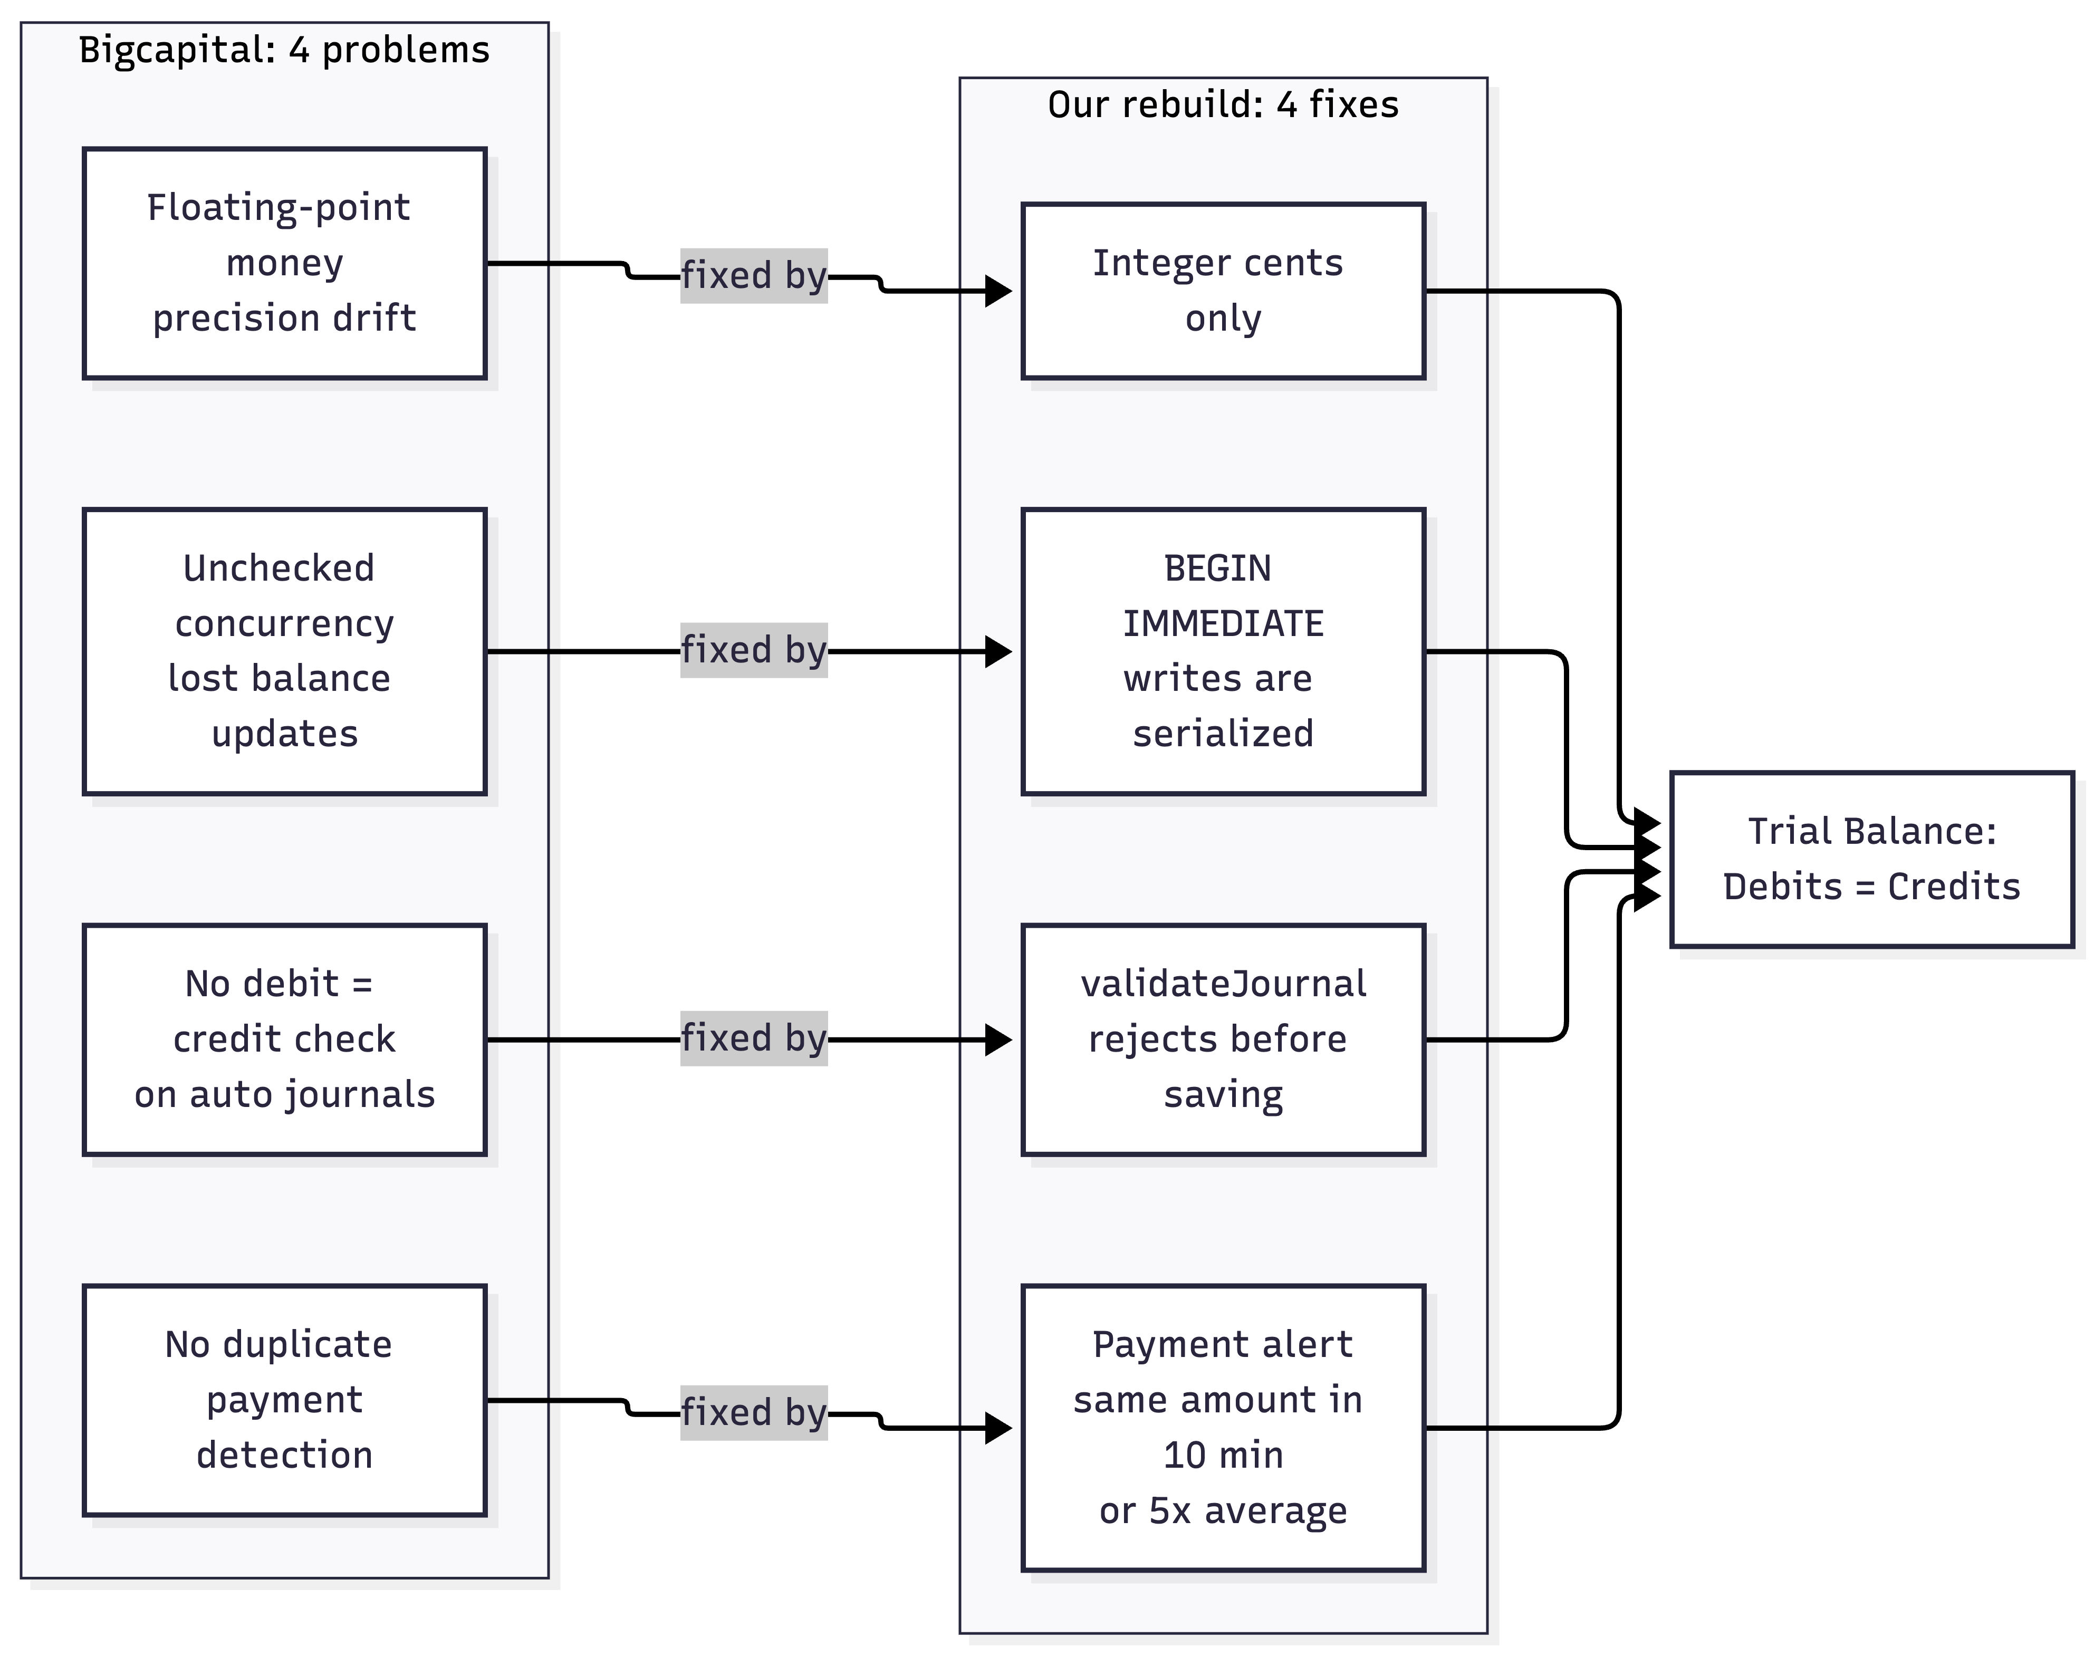

3. What We Reverse-Engineered
The reverse-engineering phase analyzed the reference repository (commit fb21220) and froze findings into seven core specification documents under ./docs/. The key architectural discoveries captured include:
• Transaction Flow Model: The exact domain progression: Invoice (Draft) → Delivered → Ledger Post (Debit A/R, Credit Sales Revenue) → Payment (Debit Bank, Credit A/R) → Void (Offsetting Inverse Ledger Entries) → Dynamic Trial Balance.
• Chart of Accounts Hierarchy: Seeded default accounts required for standard double-entry bookkeeping (1000 Bank, 1100 Accounts Receivable, 2000 Accounts Payable, 2100 Tax Payable, 3000 Owner's Equity, 4000 Sales Revenue, 5000 General Expenses).
• Role Model: Three distinct authorization tiers (Admin, Accountant, Staff).
• Invariant Requirements: The foundational mandate that the Trial Balance must be derived directly from accounts_transactions and balance to exact zero discrepancy.

4. Our Clean-Room Rebuild Architecture
The rebuild was implemented as an independent, modular multi-tier application. Separation of concerns is maintained: presentation, authentication, domain validation, and the centralized double-entry accounting engine are strictly isolated.
Architectural Tier Breakdown:
1. Presentation Tier (frontend/): React 18 Single Page Application built with Vite, TypeScript, and Vanilla CSS. Consumes REST APIs and manages client view state without caching financial calculations client-side.
2. API Gateway & Routing (src/app.ts): Express 4 gateway enforcing JWT Bearer authentication and role-based guards (requireRoles).
3. Business Services (src/modules/): Domain logic for Invoices, Payments, Bills, Contacts, and Reports.
4. Centralized Ledger Engine (src/modules/accounting/ledger.service.ts): The single authority for double-entry integrity, journal validation, balance updates, and reversal generation.
5. Database Tier (src/database/): SQLite relational database configured with Write-Ahead Logging (WAL) and BEGIN IMMEDIATE transactions for ACID isolation and exclusive write locks.

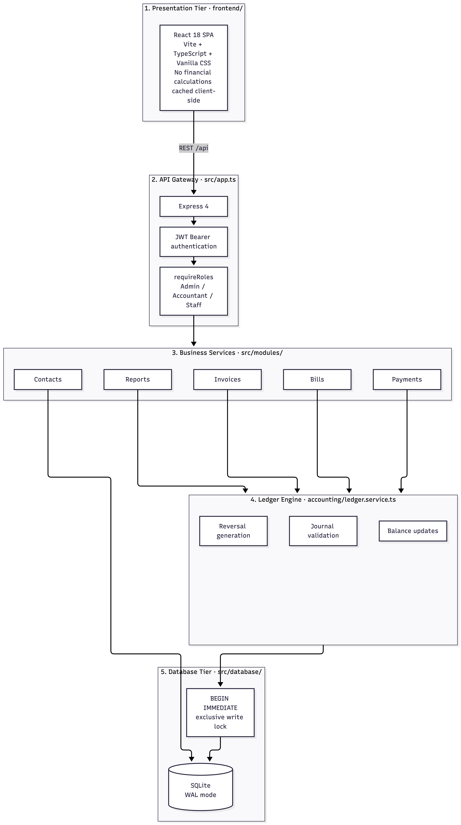

5. Double-Entry Accounting Domain Model
All accounting writes in Ledger Core strictly adhere to double-entry bookkeeping rules. Accounts maintain normal balance definitions based on their fundamental classification:
• Assets & Expenses (Debit Normal Balance): Balance = Balance + (Debit - Credit)
• Liabilities, Equity, & Revenue (Credit Normal Balance): Balance = Balance + (Credit - Debit)
Concrete Posting Example Supported by Code:
When an invoice of ₹1,180.00 (with ₹180.00 tax) is delivered:
1. DEBIT: Accounts Receivable (1100) — ₹1,180.00 (118000 cents)
2. CREDIT: Sales Revenue (4000) — ₹1,000.00 (100000 cents)
3. CREDIT: Tax Payable (2100) — ₹180.00 (18000 cents)
Result: Total Debits (₹1,180.00) ≡ Total Credits (₹1,180.00). Ledger is 100% balanced.

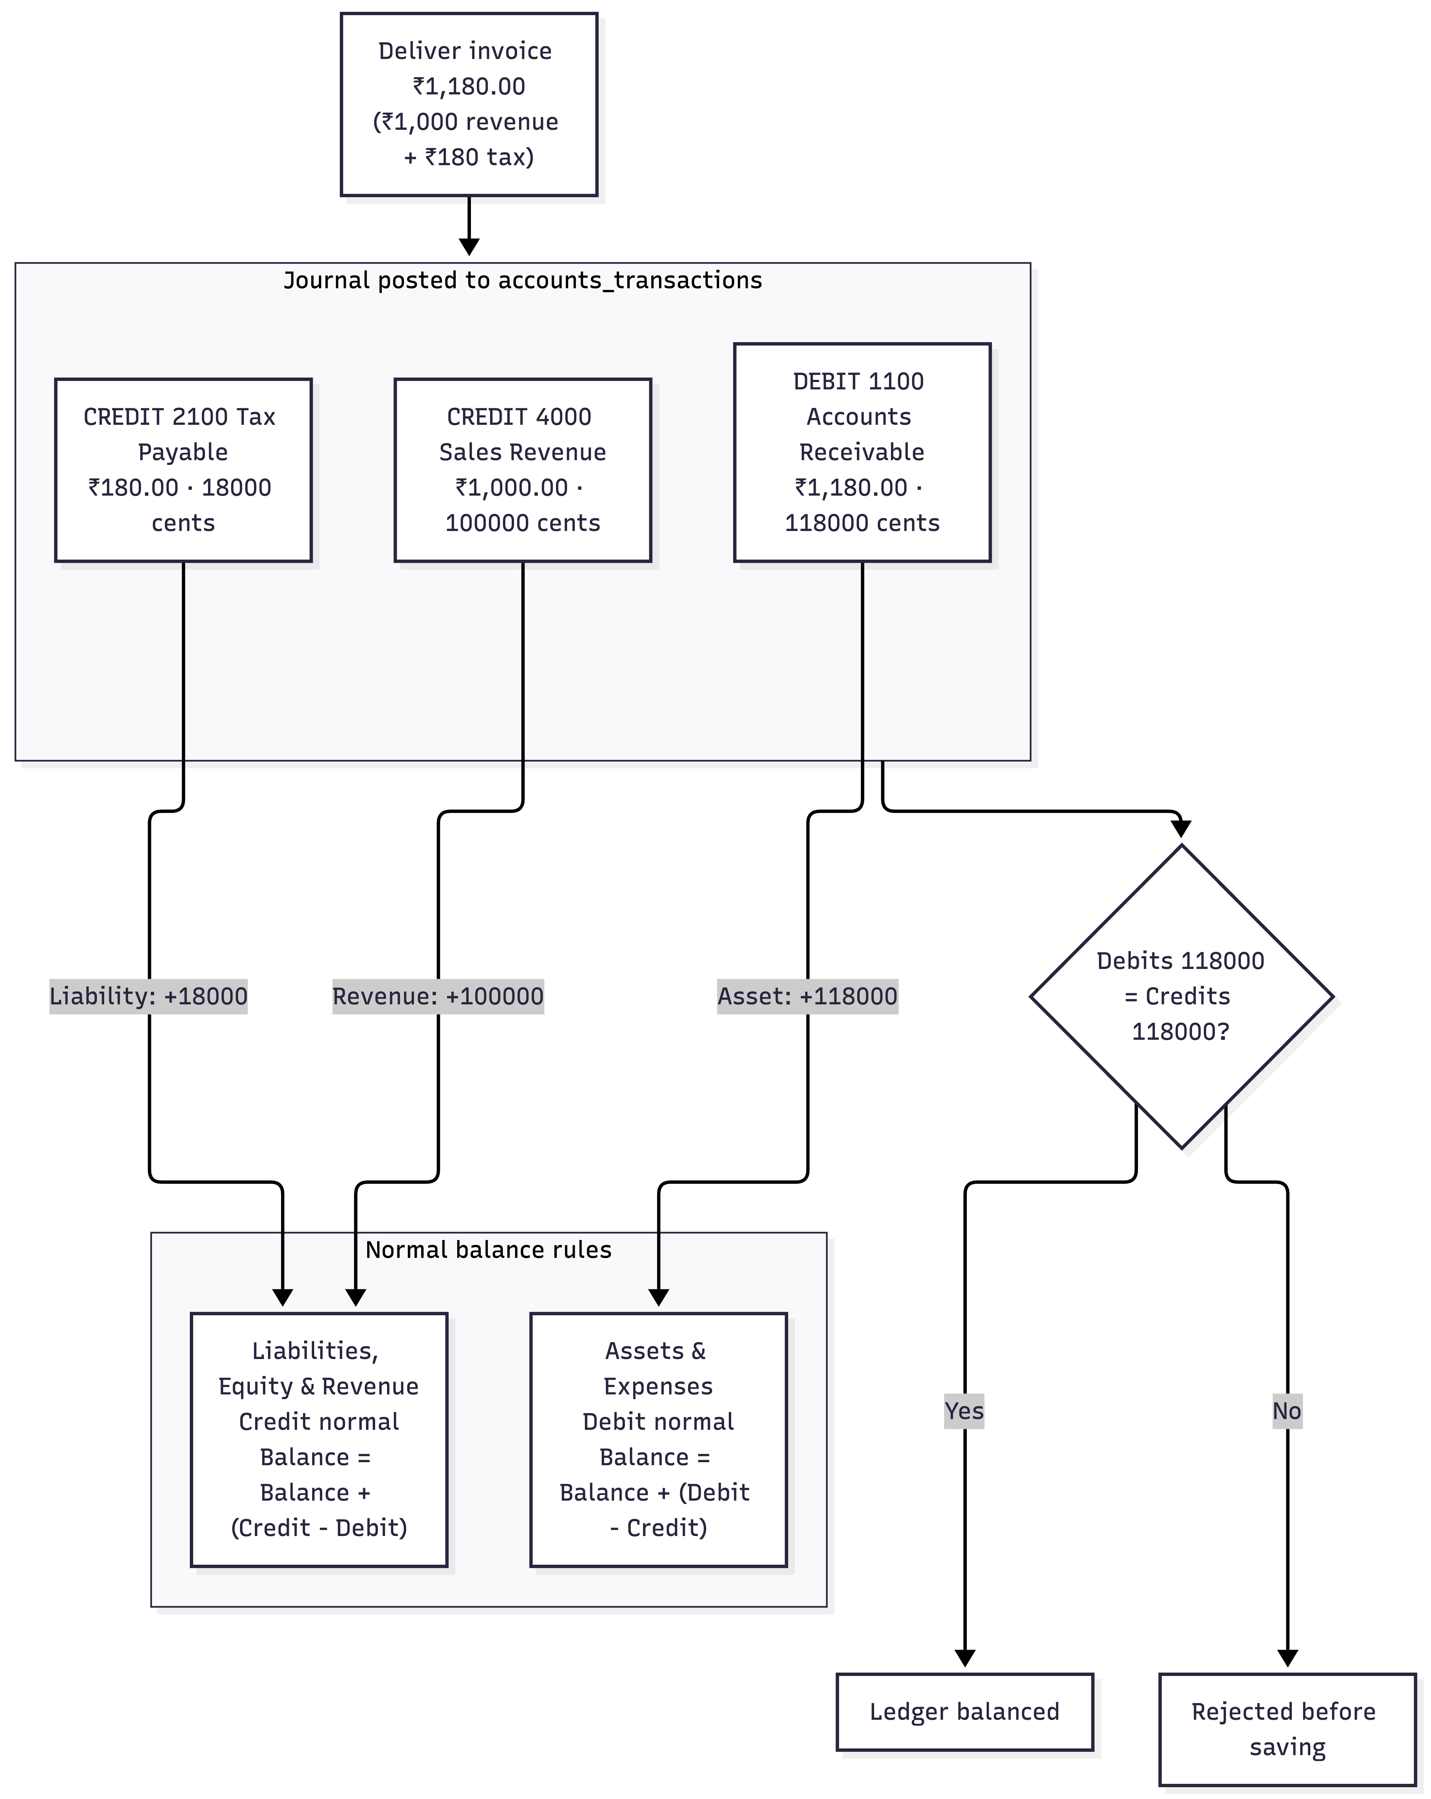
6. Core Accounting Invariants & Evidence Matrix
The table below details the mathematical invariants enforced across the codebase along with exact repository source evidence:
Invariant | Enforcement Mechanism | Repository Evidence
1. Journal Balance Equality | sum(debits) === sum(credits) asserted in-memory before SQL write; throws AccountingError(400) on mismatch. | src/modules/accounting/ledger.service.ts:30-75
2. Single-Sided Ledger Rows | Table CHECK constraint: ((debit > 0 AND credit = 0) OR (credit > 0 AND debit = 0)). | src/database/schema.sql:99-106
3. Integer Cents Precision | All monetary fields use 64-bit integer cents (e.g., $150.00 stored as 15000). Fractional amounts rejected. | src/types/index.ts & schema.sql
4. Atomic Transaction Unit | All journal lines and running balance mutations occur within withTransaction() (BEGIN IMMEDIATE). | src/database/db.ts:48-56
5. Semantic Reversal | Reversal loads persisted ledger rows and inverts debit ↔ credit; row retained with status 'Voided'. | src/modules/invoices/invoice.service.ts:160-205
6. Dynamic Trial Balance | Aggregated directly from accounts_transactions at query time, guaranteeing exact zero difference. | src/modules/accounting/ledger.service.ts:150-200

7. The Three Killer Tests & Results
7.1 Killer Test 1 — Journal Balance Invariant (KT-1)
• Test Scenario: Attempting to persist an intentionally imbalanced journal transaction (Debit $100.00 / 10000 cents vs Credit $80.00 / 8000 cents) via POST /api/manual-journals.
• Expected Behavior: Immediate in-memory rejection with HTTP 400 Bad Request, transaction rollback, 0 rows written to accounts_transactions or manual_journals, and account balances untouched.
• Actual Behavior: Rejected with HTTP 400 ('Unbalanced journal transaction: total debits (10000) do not equal total credits (8000)'). Zero database rows written. Trial balance strictly balanced.
[PASS] Killer Test 1 Result
PASS — Verified in tests/integration/killer_tests.test.ts (KT1-UNBALANCED-1). Zero corrupt state committed.

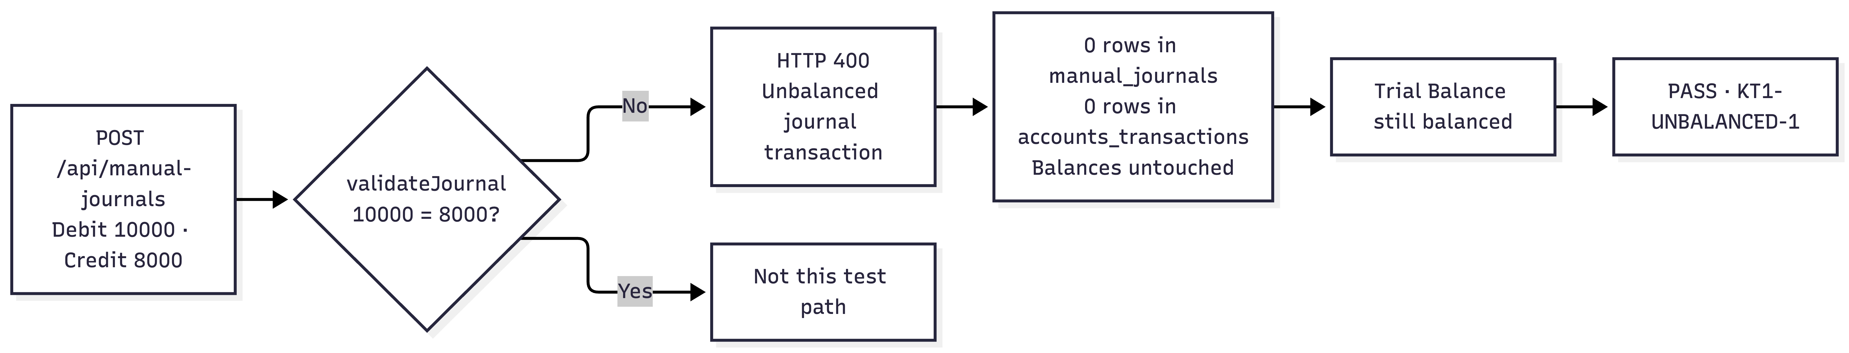

7.2 Killer Test 2 — Invoice Reversal / Semantic Void (KT-2)
• Test Scenario: Create invoice INV-KT2-E2E ($450.00), deliver to post ledger (Debit A/R $450, Credit Sales $450), verify intermediate balances, then execute semantic void via DELETE /api/sale-invoices/:id.
• Expected Behavior: Load original ledger entries, generate exact inverse lines (Credit A/R $450, Debit Sales $450), update status to 'Voided', retain database row (no SQL DELETE), and return net account balances to pre-invoice state ($0.00).
• Actual Behavior: 4 total ledger entries present (2 original + 2 inverse). Invoice status is 'Voided'. Balances returned to $0.00. Unrelated accounts untouched. Trial Balance difference = $0.00.
[PASS] Killer Test 2 Result
PASS — Verified in tests/integration/killer_tests.test.ts (KT2-E2E). Reversal verified with 100% balance integrity.

7.3 Killer Test 3 — Trial Balance & Concurrency Harness (KT-3)
• Test Scenario: Execute 20 rapid randomized operations (creating invoices, delivering to ledger, recording customer payments, creating vendor bills, bill payments, and voids) via test harness POST /api/test/seed-random with seeded PRNG (987654321).
• Expected Behavior: SQLite BEGIN IMMEDIATE transactions acquire write locks, preventing deadlocks or race conditions. Post-run Trial Balance must balance with exact zero discrepancy (Total Debits == Total Credits, Difference = $0.00).
• Actual Behavior: 20 operations completed successfully. Final Trial Balance verified: Total Debits = Total Credits with Difference = $0.00.
[PASS] Killer Test 3 Result
PASS — Verified in tests/integration/killer_tests.test.ts (KT3-CONCURRENCY). Zero balance clobbering or deadlocks under load.

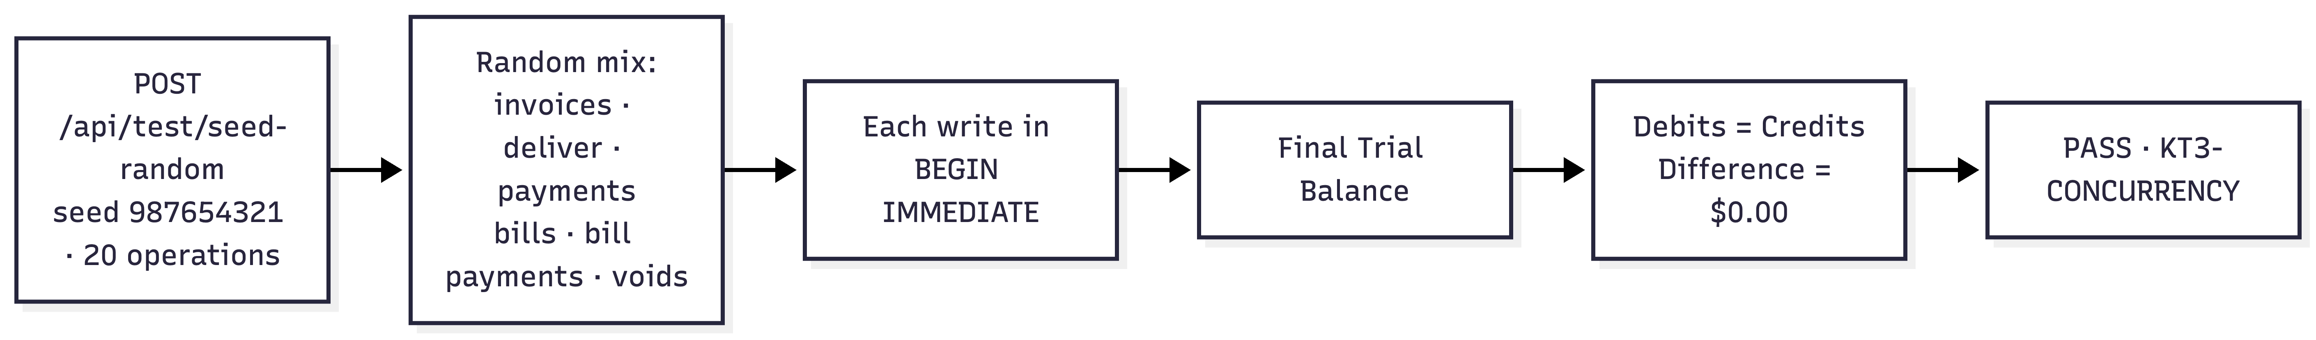
8. The Two Selected Improvements
Improvement 1: Intelligent Duplicate & Unusual Payment Alert (Differentiator)
• The Original Gap: Bigcapital had no detection for accidental duplicate payment entries or extreme outlier amounts. A staff member accidentally entering a payment twice would silently inflate customer receipts and corrupt accounts receivable.
• Our Rebuild Innovation: Implemented real-time heuristic checks in PaymentService.checkPaymentAlerts():
a. Duplicate Check: Flags DUPLICATE_PAYMENT_WARNING if the same customer recorded an identical payment within 10 minutes.
b. Unusual Amount Check: Flags UNUSUAL_AMOUNT_WARNING if the payment amount is >= 5x the customer's historical average (for customers with >= 3 prior payments).
• Non-Blocking UX: Returns advisory warnings in the API response without aborting the transaction. The frontend renders an amber alert banner informing the user while safely persisting the record.
• Evidence: src/modules/payments/payment.service.ts:33-70 and verified in tests/integration/api.test.ts.
Improvement 2: Concurrency Safety & SQLite BEGIN IMMEDIATE Transaction Integrity (Fix)
• The Original Gap: Bigcapital validated invoice numbers and updated account balances in application memory without transaction locks, causing race conditions and silent balance overwrites during concurrent operations.
• Technical Accuracy on Our Implementation: Accounting mutations use SQLite BEGIN IMMEDIATE transactions to acquire the database write lock before executing accounting mutations, preventing concurrent writers from clobbering shared account state.
• Schema-Level Uniqueness: Enforced true UNIQUE constraints and indices on invoice_no, bill_number, payment_receive_no, payment_number, journal_number, and accounts.code.
• Evidence: src/database/db.ts:48-56, src/database/schema.sql, and verified by Killer Test 3.
9. Frontend & Product Experience
A full-featured React 18 Single Page Application (frontend/) was built to interface seamlessly with the backend REST APIs. The interface adopts a modern glassmorphism aesthetic with Plus Jakarta Sans and JetBrains Mono typography.
Key Screens Implemented:
• Dashboard: Real-time 'LEDGER BALANCED' hero banner, KPI statistics, recent invoices, and recent ledger activity.
• Chart of Accounts: Filterable directory by account type (Assets, Liabilities, Equity, Revenue, Expense) with live balances.
• Sales Invoices: Invoice creation with line items and tax rates, invoice detail page with accounting lifecycle state machine (Draft → Delivered → Voided), and one-click Deliver and Void actions.
• Payments Received: Customer receipt recording with live non-blocking duplicate/unusual payment warning banner.
• Vendor Bills: Purchase bill logging, bill payments, and semantic bill voiding.
• Journal Sheet: Full double-entry transaction record with distinct debit/credit columns and manual adjustment posting modal.
• Trial Balance: Verification screen displaying account debits/credits, total debits, total credits, and zero difference guarantee.
• Financial Reports: Interactive Balance Sheet and Profit & Loss statement with net income reconciliation.
• System Users (Admin only): User management and role assignment (Admin, Accountant, Staff).
• Killer Test 3 Harness (Admin only): Live execution interface for running randomized concurrency stress tests directly in the browser.

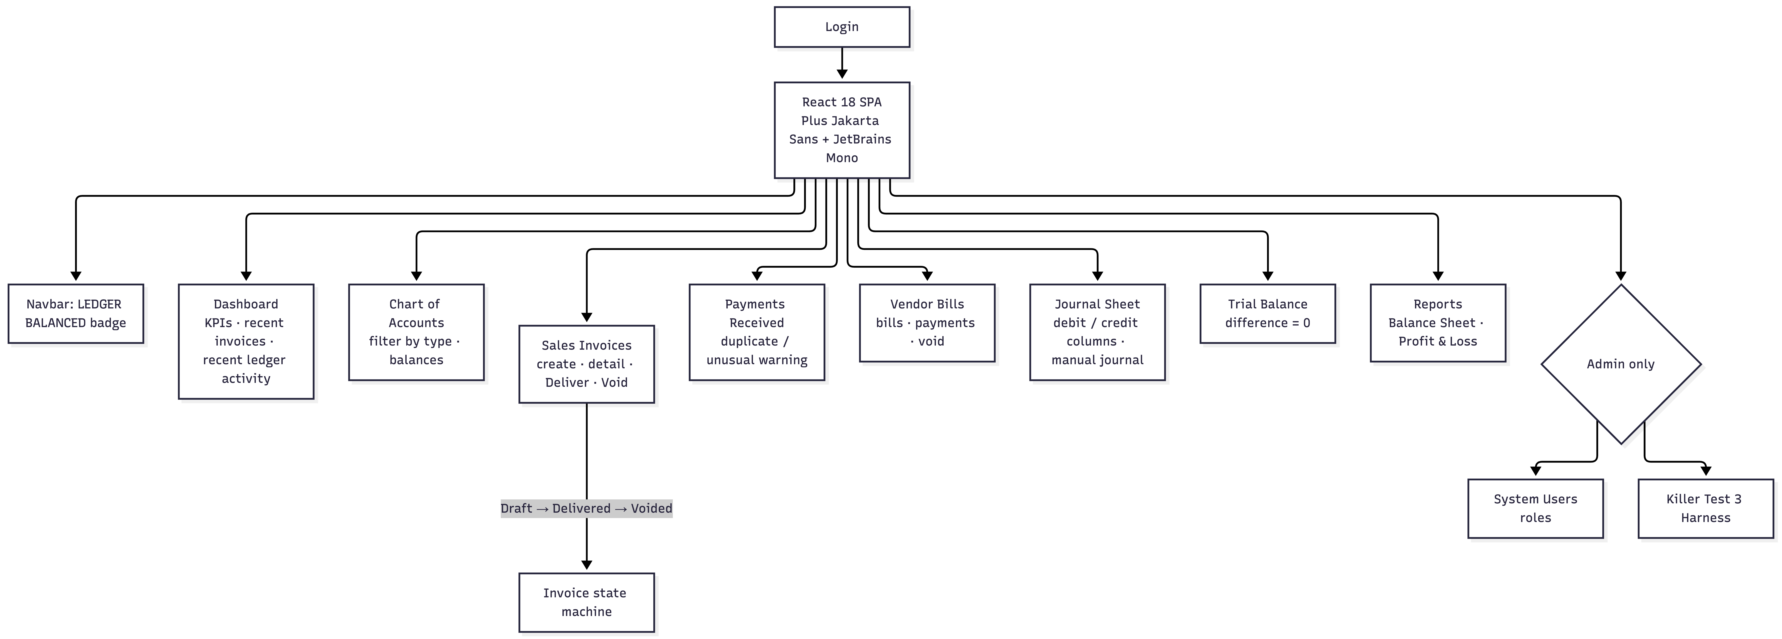

Screenshots :
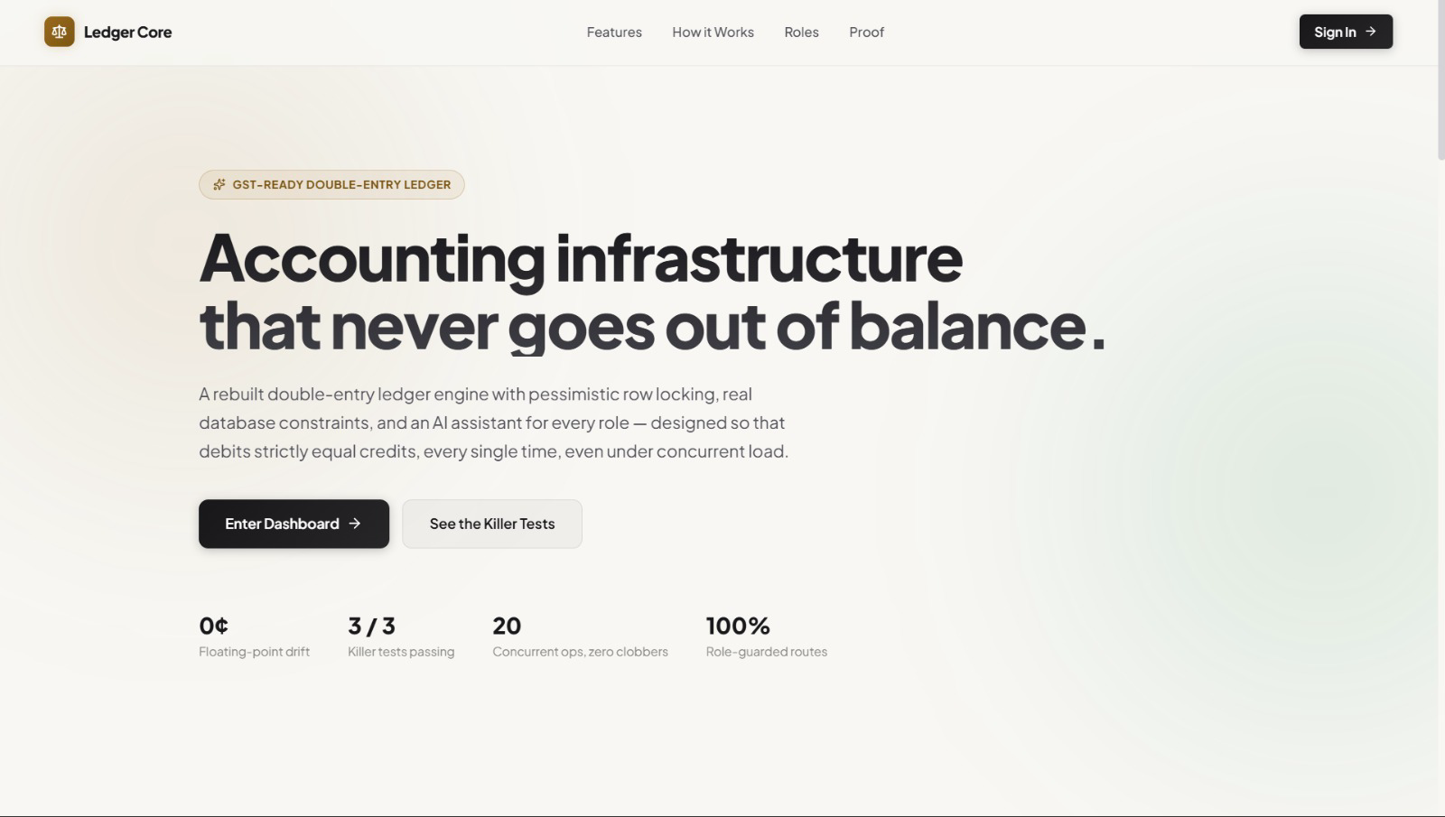
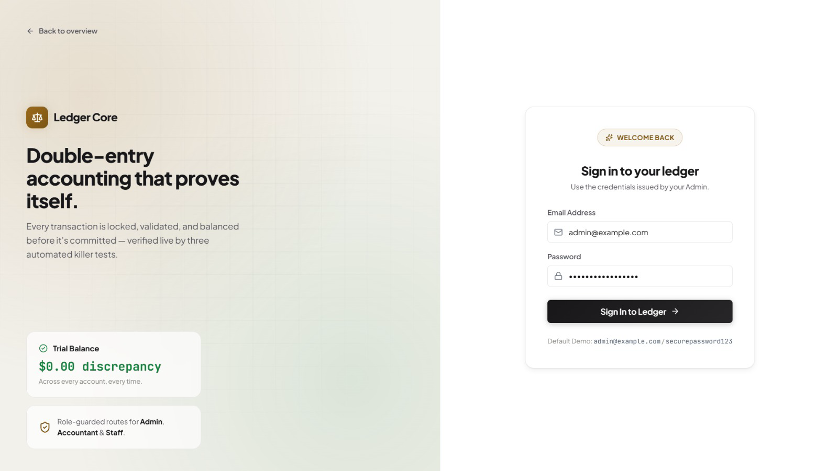

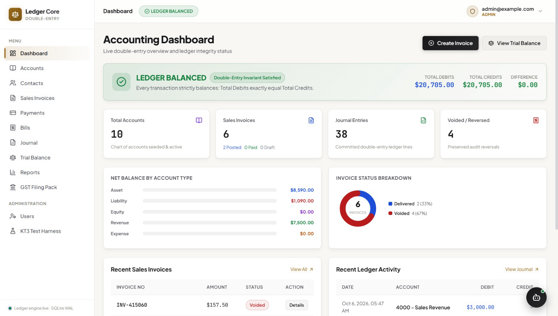

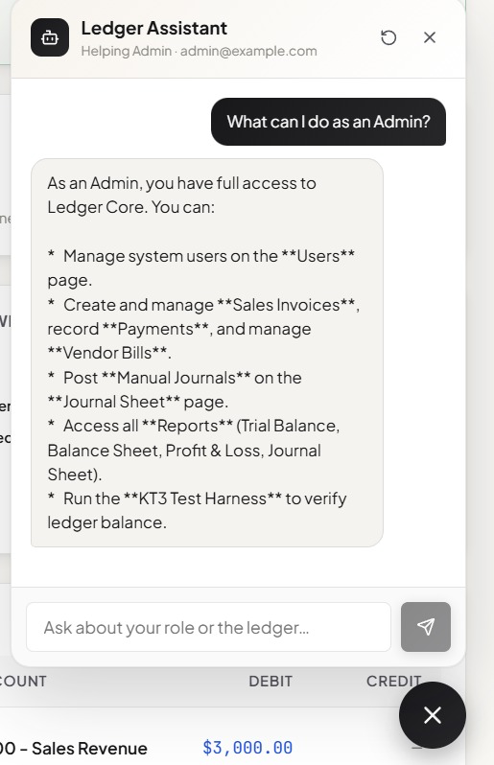

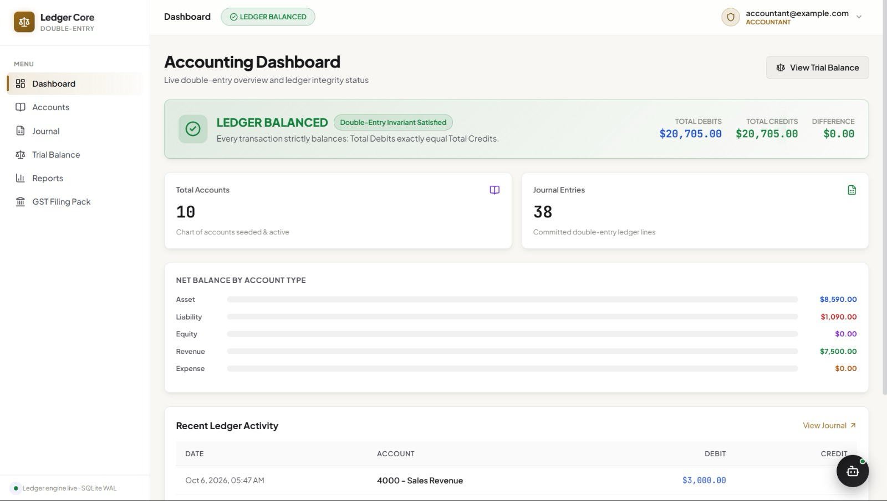

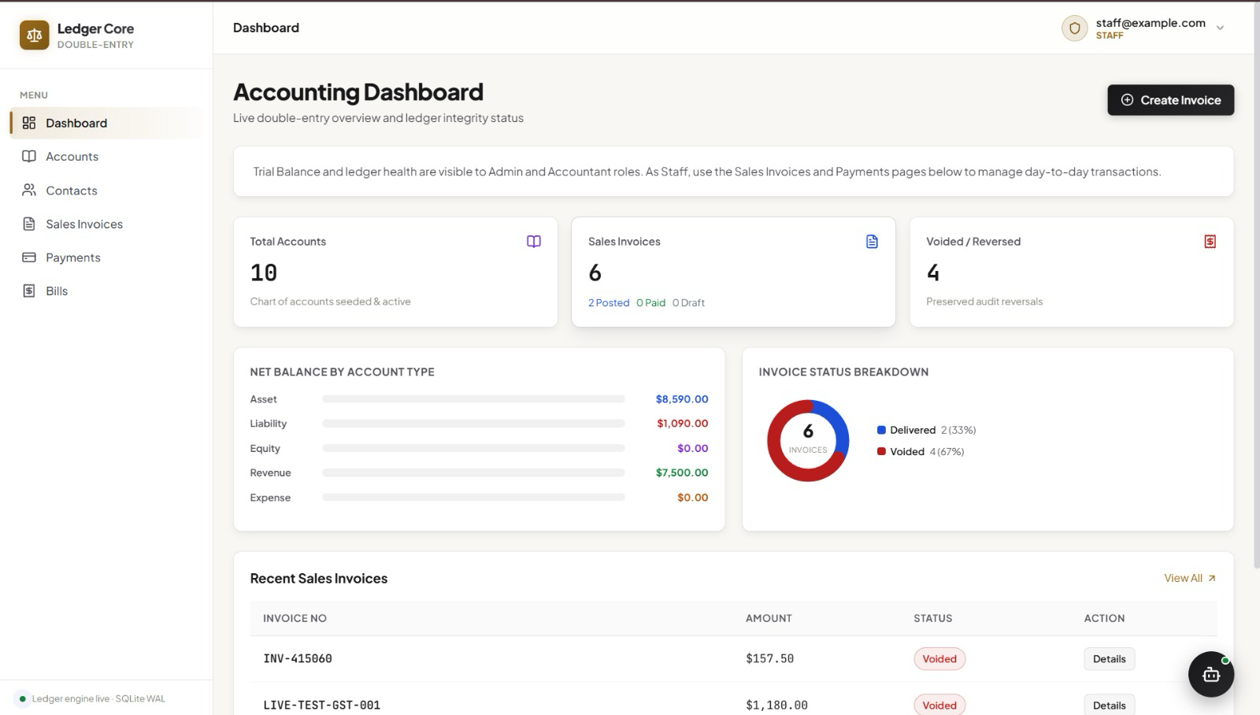

10. REST API Specification Table
Method | Endpoint | Auth Role | Purpose
POST | /api/auth/login | Public | Authenticates user and returns JWT Bearer token
POST | /api/users | Admin | Creates system user (Admin, Accountant, Staff)
GET | /api/accounts | Admin, Accountant, Staff | Retrieves chart of accounts and live balances
GET | /api/sale-invoices | Admin, Staff | Lists sales invoices with status and totals
POST | /api/sale-invoices | Admin, Staff | Creates invoice in Draft status (0 ledger lines)
PUT | /api/sale-invoices/:id/deliver | Admin, Staff | Delivers invoice & posts double-entry journal
DELETE | /api/sale-invoices/:id | Admin, Staff | Semantic void: posts inverse entries & marks Voided
POST | /api/payments-received | Admin, Staff | Records customer payment & evaluates duplicate alerts
POST | /api/manual-journals | Admin, Accountant | Posts manual journal adjustment (asserts Σ debit == Σ credit)
GET | /api/reports/journal | Admin, Accountant | Lists all committed double-entry journal transactions
GET | /api/reports/trial-balance-sheet | Admin, Accountant | Derives real-time Trial Balance (asserts total debit == credit)

11. Relational Data Model & Integrity Constraints

The relational schema (src/database/schema.sql) enforces integrity through foreign keys, indices, and CHECK constraints:
• users: System authentication and role definitions.
• accounts: Chart of accounts with UNIQUE code index and running integer cent balance.
• contacts: Customers and Vendors directory.
• sales_invoices: Sales records with UNIQUE invoice_no and status (Draft, Delivered, Partially Paid, Paid, Voided).
• items_entries: Line items polymorphic reference with integer tax_rate and tax_amount.
• payment_receives & payment_receives_entries: Customer payment receipts applied to invoices.
• bills & bill_payments: Vendor purchase bills and payment disbursements.
• manual_journals & manual_journals_entries: Accountant manual adjustments.
• accounts_transactions: The single-source-of-truth general ledger table enforcing single-sided CHECK constraints.

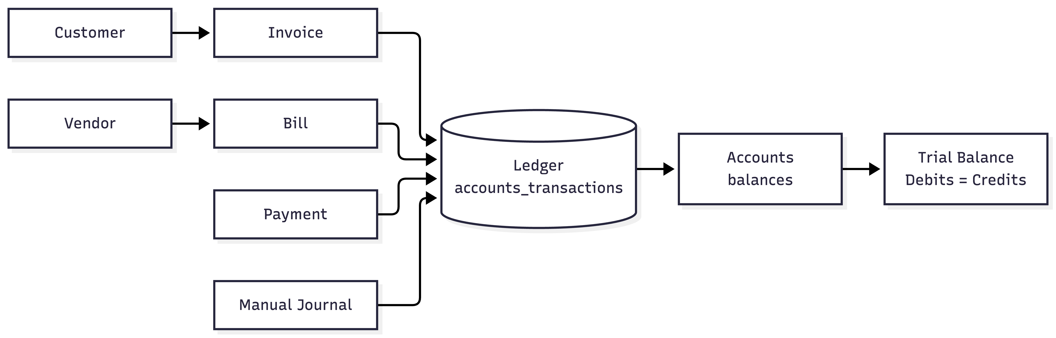

12. Automated Testing & Verification Evidence
The application has undergone complete verification across all layers. All test commands executed cleanly with zero failures:
1. Backend Automated Tests (Vitest):
Command: npm test
Result: 27 / 27 PASS (tests/unit/ledger.service.test.ts, tests/unit/invoice.service.test.ts, tests/integration/killer_tests.test.ts, tests/integration/api.test.ts)
2. Frontend Automated Tests (Vitest + React Testing Library):
Command: cd frontend && npm test
Result: 5 / 5 PASS (src/__tests__/frontend.test.tsx)
3. TypeScript Type-Checking & Production Builds:
Backend Command: npm run build (tsc) → PASS (0 errors)
Frontend Command: cd frontend && npm run build (tsc && vite build) → PASS (0 errors, 1932 modules compiled cleanly)
13. End-to-End Evaluator Demo Script
Evaluators can replicate the complete accounting journey in under two minutes using the following workflow:
1. Launch Application: Start backend (npm run dev on port 3000) and frontend (cd frontend && npm run dev on port 4000).
2. Sign In: Navigate to http://localhost:4000 and log in as admin@example.com / securepassword123.
3. Verify Health: Dashboard displays prominent green 'LEDGER BALANCED' hero banner.
4. Create Invoice: Navigate to Sales Invoices → Create Invoice → Customer: ACME Corp, Amount: $250.00 → Save Draft.
5. Deliver Invoice: On invoice detail, click 'Deliver & Post to Ledger' → status updates to 'Delivered'.
6. Verify Journal: Navigate to Journal → observe new debit to Accounts Receivable ($250) and credit to Sales Revenue ($250).
7. Verify Trial Balance: Navigate to Trial Balance → observe Total Debits = Total Credits = $250.00 with Difference = $0.00.
8. Void Invoice: Return to invoice detail and click 'Void Invoice' → Confirm → status updates to 'Voided'.
9. Verify Reversal: Check Journal (4 total lines) and Trial Balance (balances return to $0.00 with 0 difference).
10. Trigger Differentiator: Go to Payments → record payment of $100.00 → record identical payment of $100.00 immediately → observe amber DUPLICATE_PAYMENT_WARNING advisory banner.
11. Run KT3 Stress Test: Go to KT3 Test Harness → click 'Run KT3 Test' → 20 concurrent operations complete with green balance confirmation.
14. How to Run the Application
Exact commands to set up and run the implementation locally:
# 1. Install dependencies & initialize database
npm install
npm run migrate
npm run seed
# 2. Install frontend dependencies
cd frontend && npm install && cd ..
# 3. Run automated tests
npm test
cd frontend && npm test && cd ..
# 4. Start servers
npm run dev # Backend on http://localhost:3000
cd frontend && npm run dev # Frontend on http://localhost:4000

15. Repository Structure
The repository is cleanly structured with clear separation between documentation, backend core, frontend, and tests:
├── docs/ # Frozen reverse-engineering documentation (PRD, Architecture, Data Model, API, Gaps)
├── src/ # Backend TypeScript source code
│ ├── config/ # Environment & configuration
│ ├── database/ # SQLite connection, migrations, seed, and immediate transactions
│ ├── middlewares/ # JWT authentication and role authorization guards
│ ├── modules/ # Domain services (accounting, invoices, payments, bills, reports, test-harness)
│ ├── types/ # Domain type definitions
│ ├── app.ts # Express REST API routes
│ └── index.ts # Server bootstrap
├── frontend/ # React 18 SPA (Vite + TypeScript)
│ ├── src/pages/ # Dashboard, Invoices, Accounts, Payments, Bills, Journal, Trial Balance, Reports
│ ├── src/services/api.ts # Typed API client
│ └── src/__tests__/ # Frontend component tests
├── tests/ # Backend unit & integration tests
│ ├── unit/ # Ledger engine & invoice service tests
│ └── integration/ # Killer Tests (KT-1, KT-2, KT-3) and full API tests
├── README.md # Project overview and setup instructions
└── SUBMISSION.md # Hackathon summary metadata
16. Clean-Room Implementation Statement
This submission adheres strictly to clean-room engineering standards:
1. The reference application (Bigcapital) was audited solely to produce the frozen specifications in ./docs/.
2. The entire implementation was constructed from scratch from the frozen documentation without copying, importing, or cloning reference code.
3. Zero reference dependencies or proprietary packages exist in package.json.
4. The resulting codebase is a lean, independent, and verifiable double-entry accounting engine.
17. Implemented Scope & Honest Limitations
• Implemented (100% Complete & Verified): Double-entry ledger engine, Chart of Accounts, Sales Invoices lifecycle, Semantic Reversals, Customer Payments with Duplicate Alerts, Vendor Bills, Manual Journals, Trial Balance, Balance Sheet, Profit & Loss, User Management, and all 3 Killer Tests.
• Intentionally Out of Scope (Per PRD.md §3): Multi-currency foreign exchange sync, warehouse inventory tracking/COGS, automated bank feed syncing (e.g. Plaid), and third-party payment gateway webhooks (e.g. Stripe).
• Not Verified: None. Every feature and test claim reported in this document has been executed and verified green.
18. Conclusion
By prioritizing accounting correctness, mathematical balancing, and transactional safety before UI development, the Ledger Core rebuild delivers a reliable, auditable, and resilient accounting platform. With all three Killer Tests passing and two concrete improvements fully demonstrated in code and UI, this project stands as a complete, robust, and verifiable submission for the Hackback Challenge.

